Database System Engineering and Distributed Backend Development
Course Code: 25CS1302E
04 joins and set operations
Name: B. Pranavi
Roll no: 2520030026
Query 1:
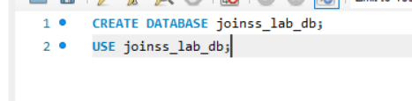
Output:
Query 2:
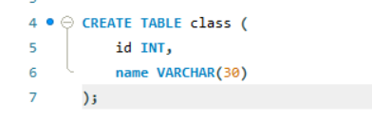
Output:
Query 3:
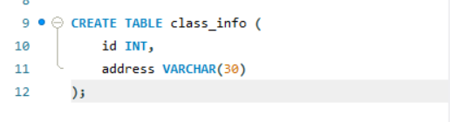
Output:
Query 4:
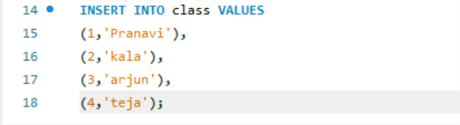
Output:
Query 5:
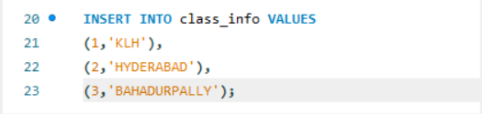
Output:
Query 6:
Output:
Query 7:
Outpiut:
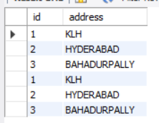
Query 8:
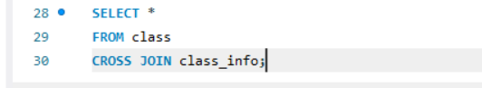
Output:
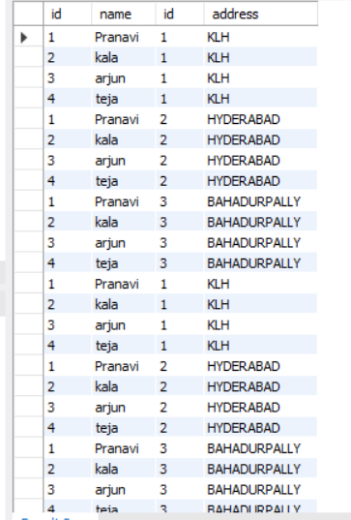
Query 9:
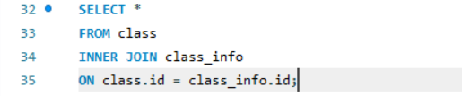
Output:
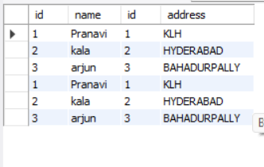
Query 10:
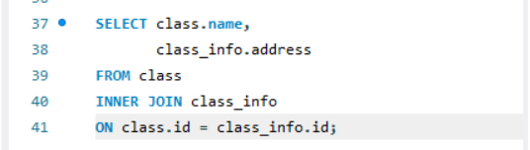
Output:
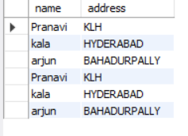
Query 11:
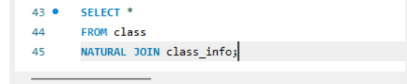
Output:
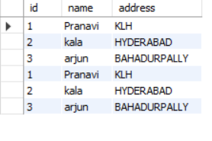
Query 12:
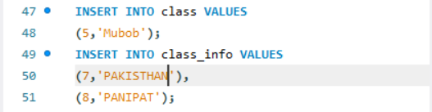
Output:
Query 13:
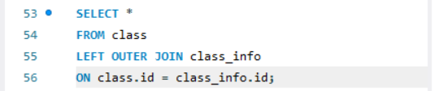
Output:
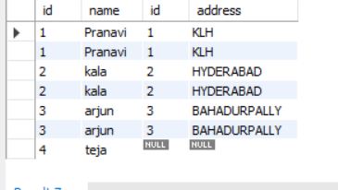
Query 14:
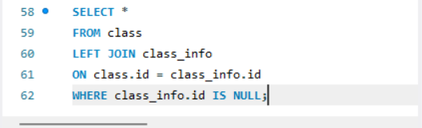
Output:
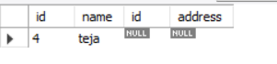
Query 15:
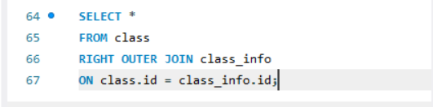
Output:
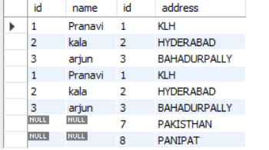
Query 16:
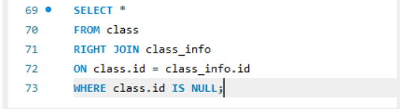
Output:
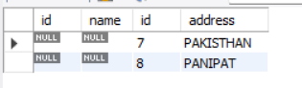
Query 17:
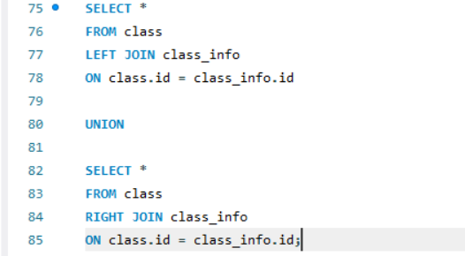
Output:
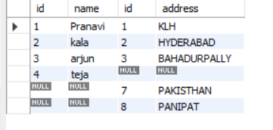
Query 18:
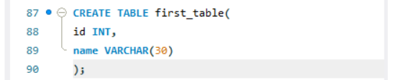
Output:
Query 19:
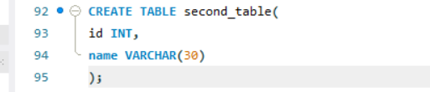
Output:
Query 20:
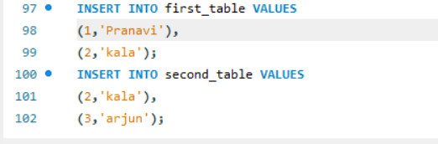
Output:
Query 21:
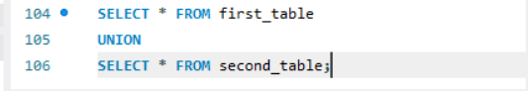
Output:
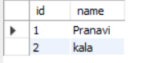
Query 22:
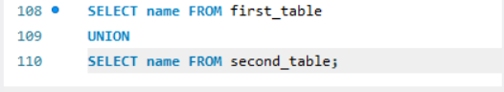
Output:
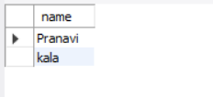
Query 23:
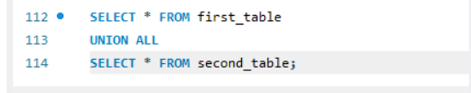
Output:
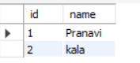
Query 24:
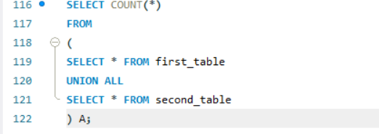
Output:
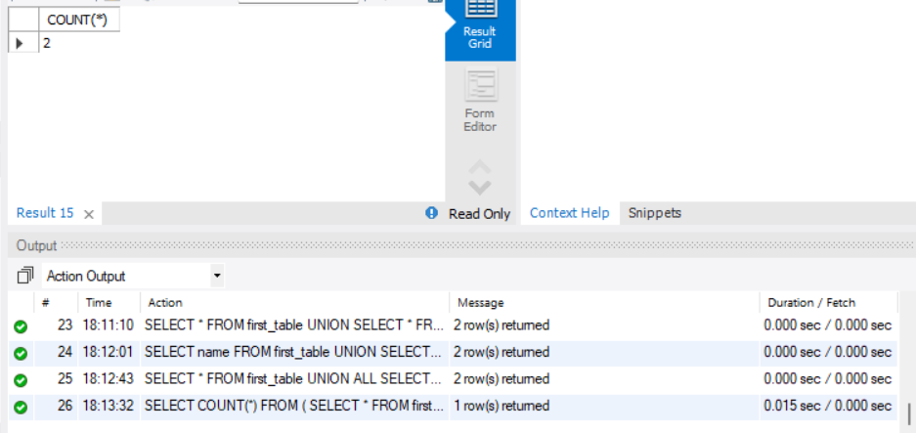
Query 25:
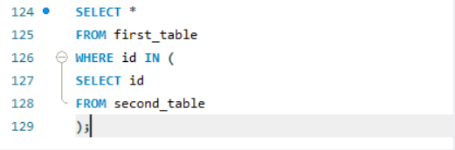
Output:
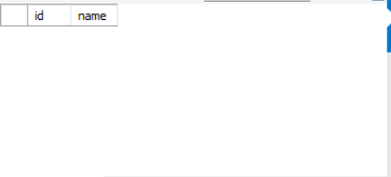
Query 26:
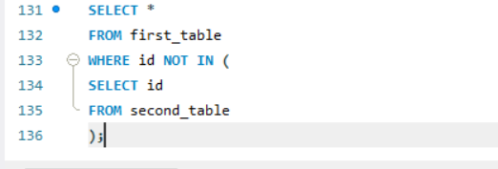
Output:
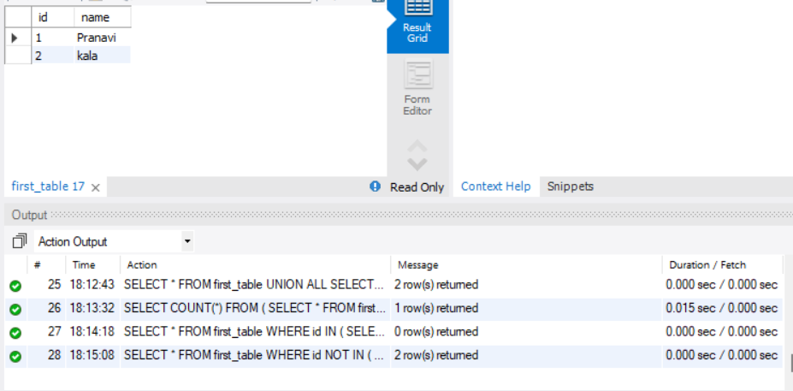
Query27:
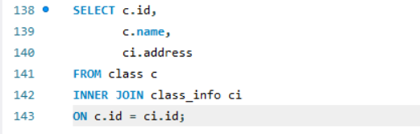
Output:
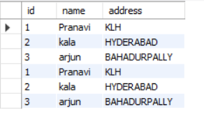
Query 28:
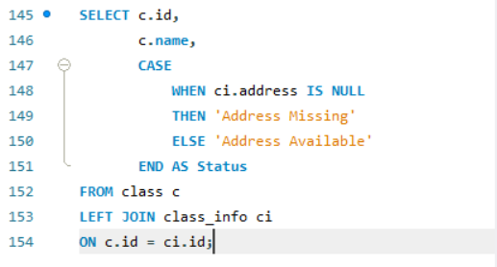
Output:
